**🛠️ Essential VLSI Tools Installation Guide**

Welcome to your first step in the RISC-V SoC design journey! 🚀  
This guide provides clear, step-by-step instructions to install the fundamental tools required for digital design, simulation, and layout. Each section includes installation commands and a visual confirmation of a successful setup.

**1. 🌟 Yosys – RTL Synthesis Tool**

Yosys is a powerful framework for Verilog RTL synthesis. It converts high-level hardware descriptions into gate-level netlists.

**🔧 Installation**

sudo apt update

sudo apt install yosys -y

**✅ Verification**

Launch Yosys to verify the installation:

Yosys

A successful installation will display the Yosys command prompt, as shown below:  
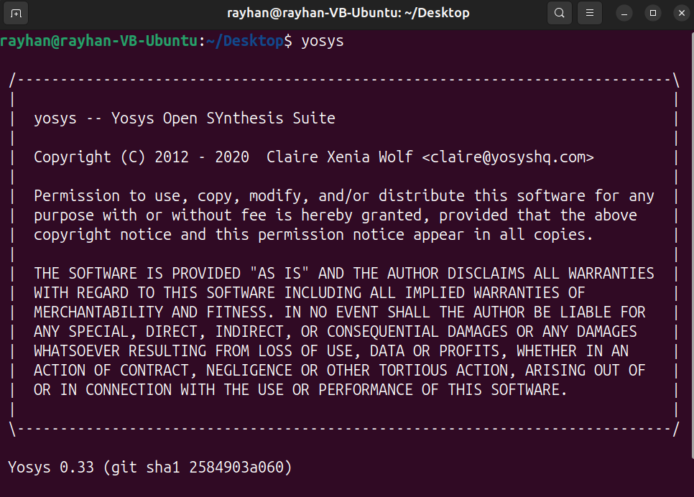

**2. 🧩 Icarus Verilog – Simulation Tool**

Icarus Verilog is a Verilog simulation and synthesis tool, used for compiling and simulating digital designs.

**🔧 Installation**

sudo apt install iverilog -y

**✅ Verification**

Run Icarus Verilog to check the installation:

Iverilog -v

The output should confirm the tool is ready for use:  
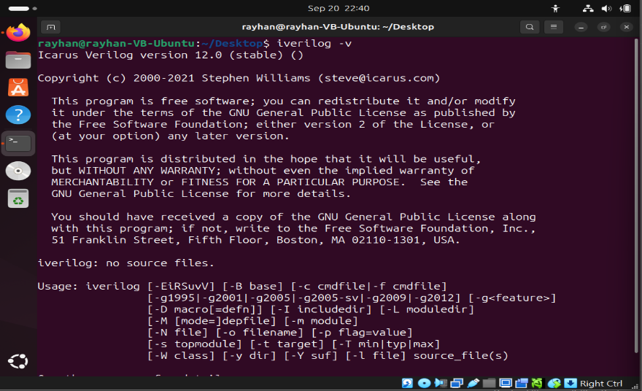

**3. 📈 GTKWave – Waveform Viewer**

GTKWave is a waveform viewer used for visualizing digital simulation outputs (VCD files).

**🔧 Installation**

sudo apt install gtkwave -y

**✅ Verification**

Start GTKWave to open its graphical interface:

gtkwave

The application window should appear as shown:  
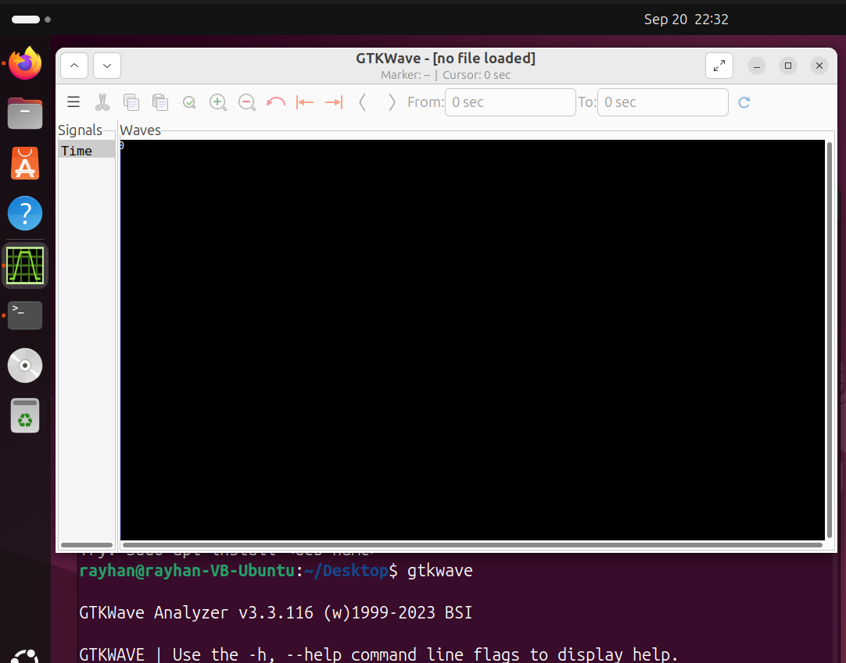

**4. ⚡ Ngspice – Circuit Simulator**

Ngspice is a mixed-level analog and digital circuit simulator, based on the SPICE platform.

**🔧 Installation**

sudo apt install ngspice -y

**✅ Verification**

Launch the Ngspice interactive console:

ngspice

You should see the Ngspice command prompt:  
  
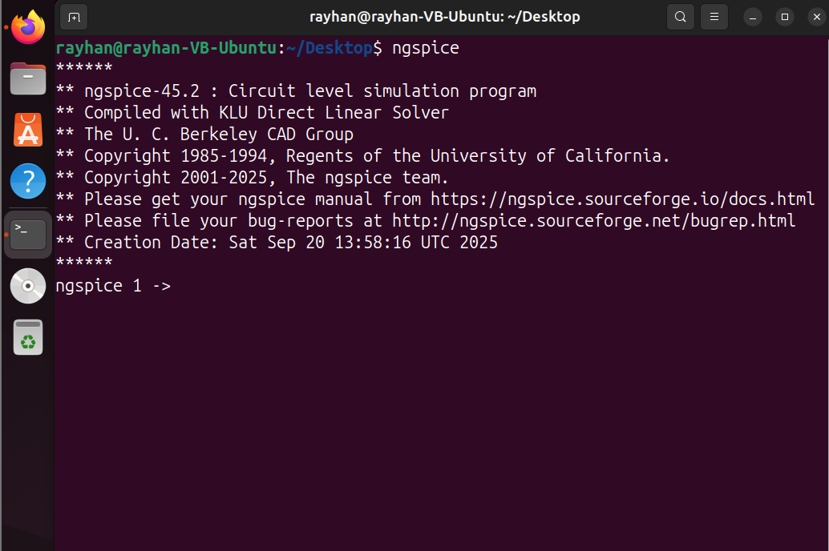

**5. 🏰 Magic – VLSI Layout Tool**

Magic is a widely-used tool for VLSI layout design and verification, supporting design rule checking (DRC) and more.

**🔧 Installation**

sudo apt install magic -y **✅ Verification**

Run Magic to start the layout editor:

magic

The layout window and toolbox will open:  
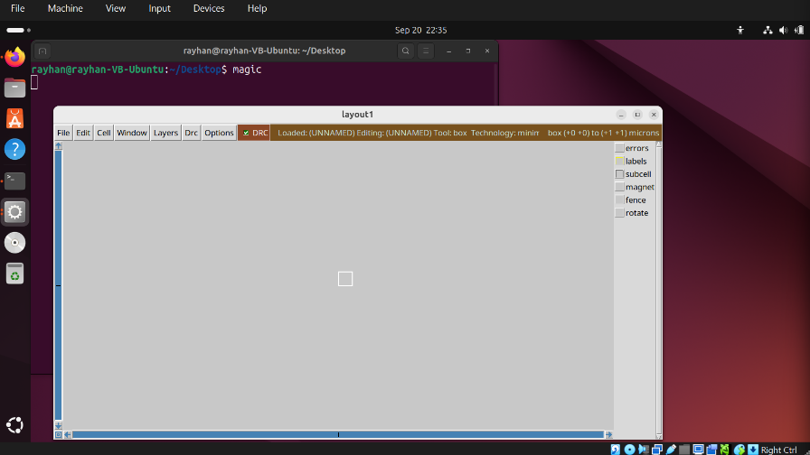

**🎯 Final Steps**

* ✅ **Verify Each Tool**: Launch each application as described to ensure everything is functioning correctly.
* 🎉 **You're All Set!** With these tools installed, you have a complete environment for RTL design, simulation, and physical layout.
* 🚀 **Happy Designing!** May your designs be efficient and your tapeouts successful.